# Task 3: **Task 3: Review Submission**

**Objective**

* Create a review form with a 1-5 rating and comment field.
* Store reviews locally in state.
* Document backend integration for later.

Pictures for how the website look like currently

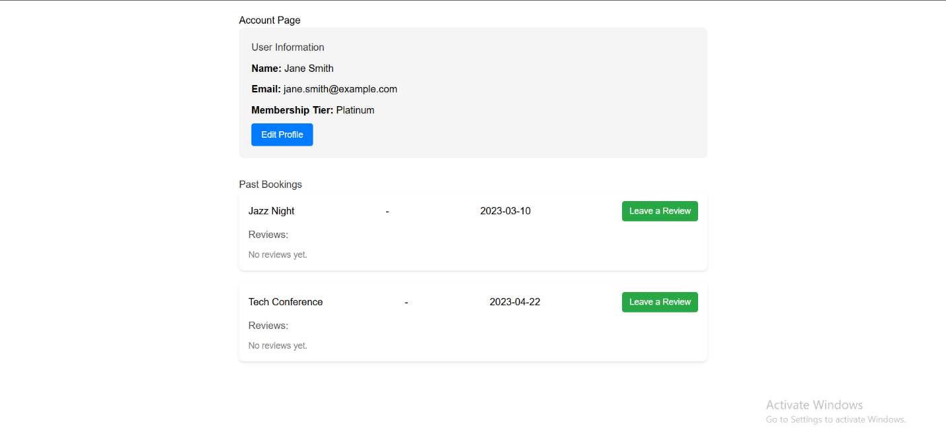

When you click on Leave a Review

It shows a Form (ReviewForm Component I made in the Code)

You write the Rating and the comment and then submit the Review

I added some constrains so the user couldn’t can’t add a rating more than 5

I added some styles for the form and the reviews

I documented how to finalize integration with the real back end in the code

If you have edits I would be happy to know them

Greatings

Mohammed Elbanawey